Q1
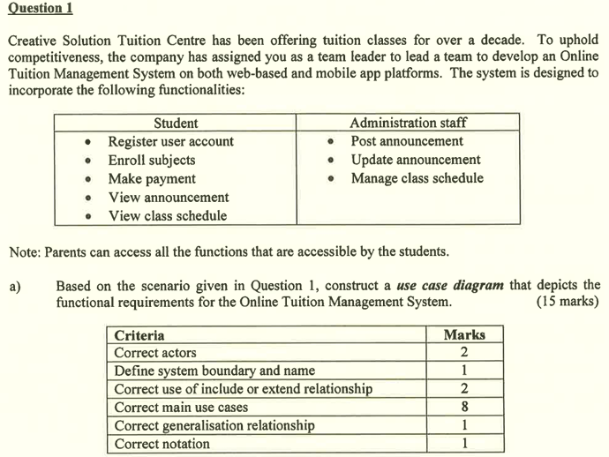

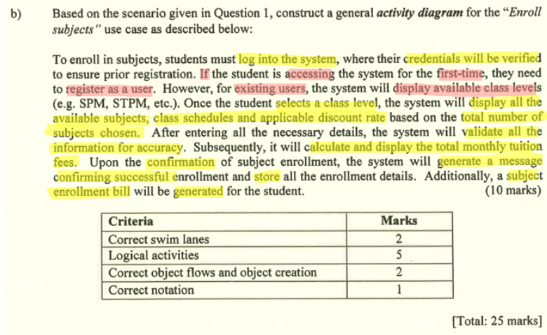

Q2
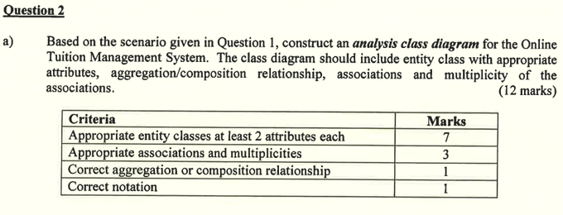
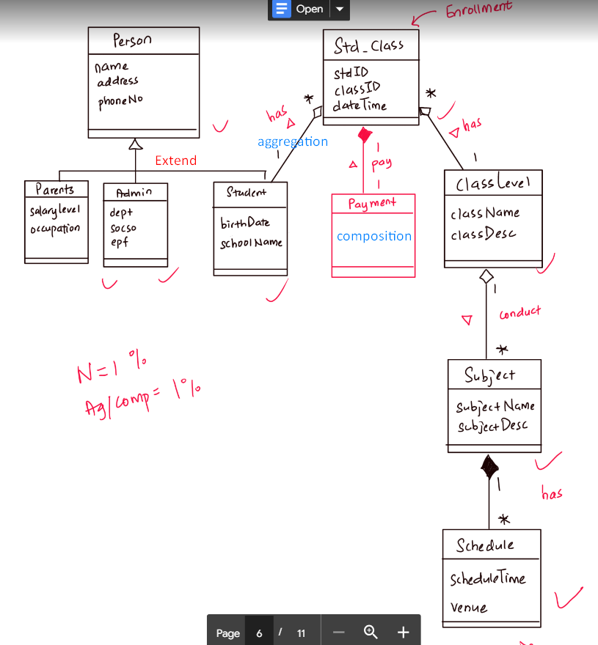

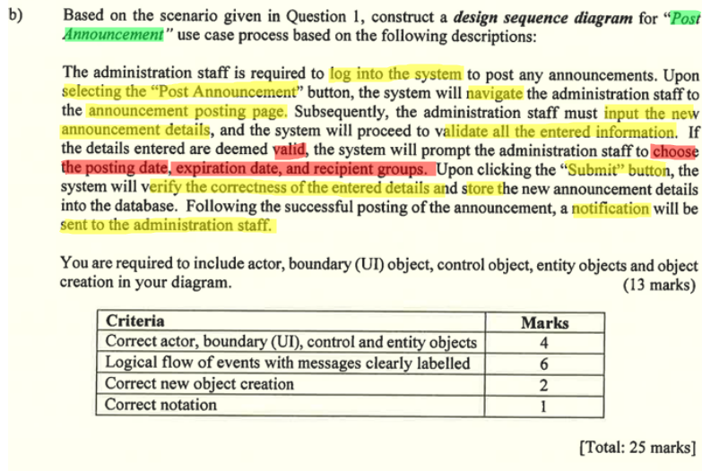

Q3
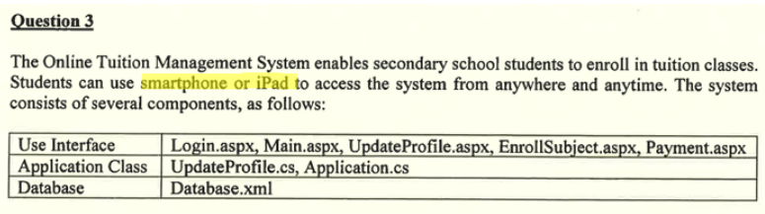
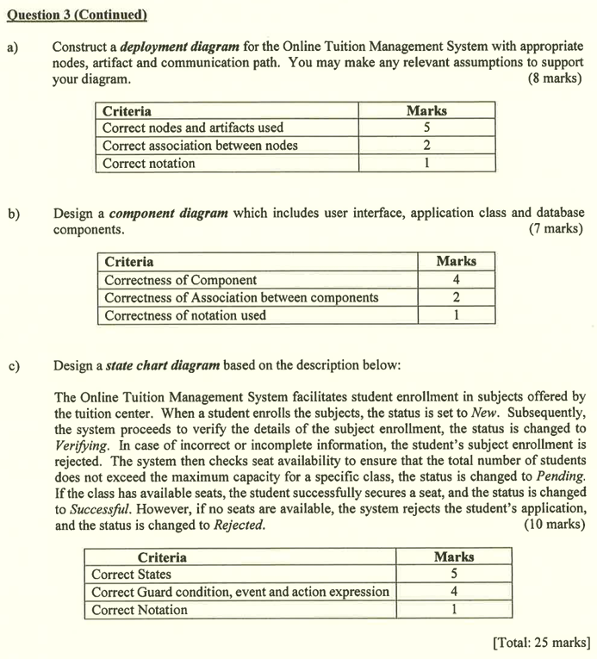
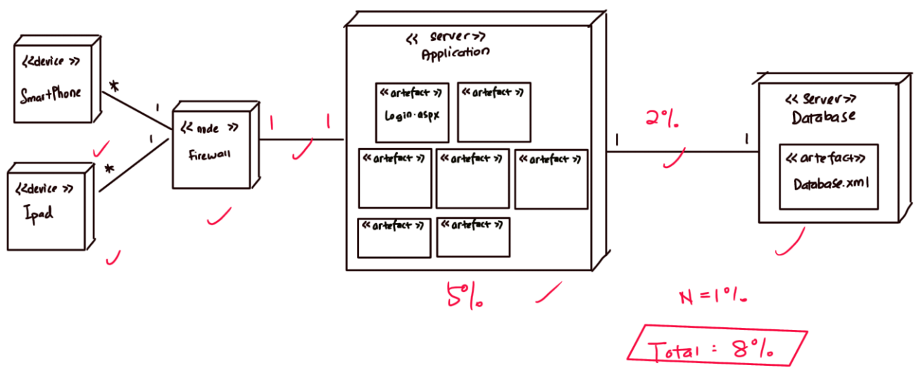

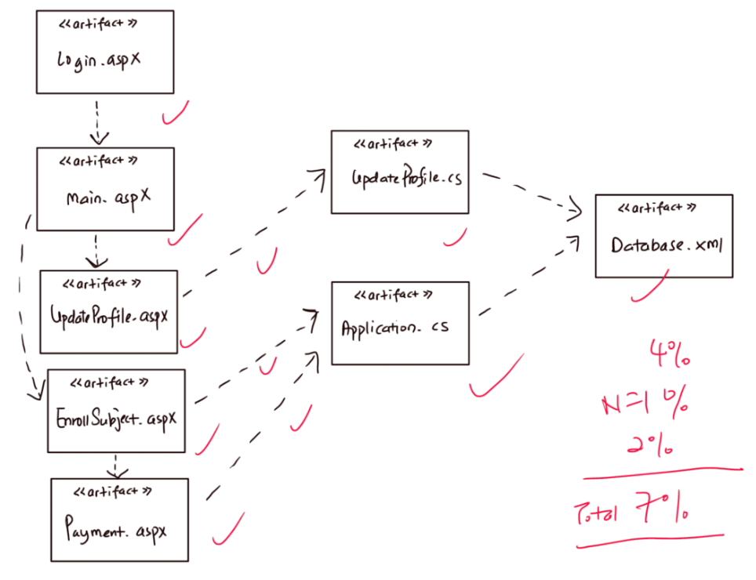

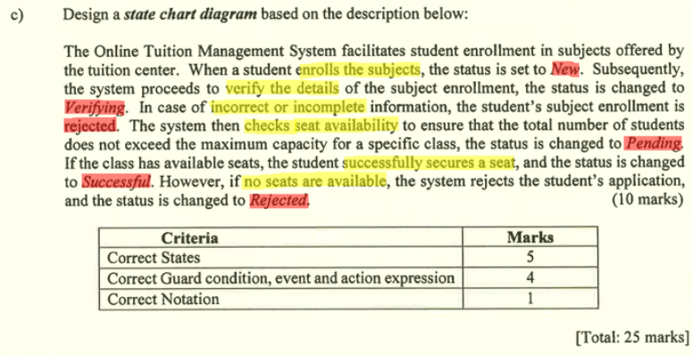
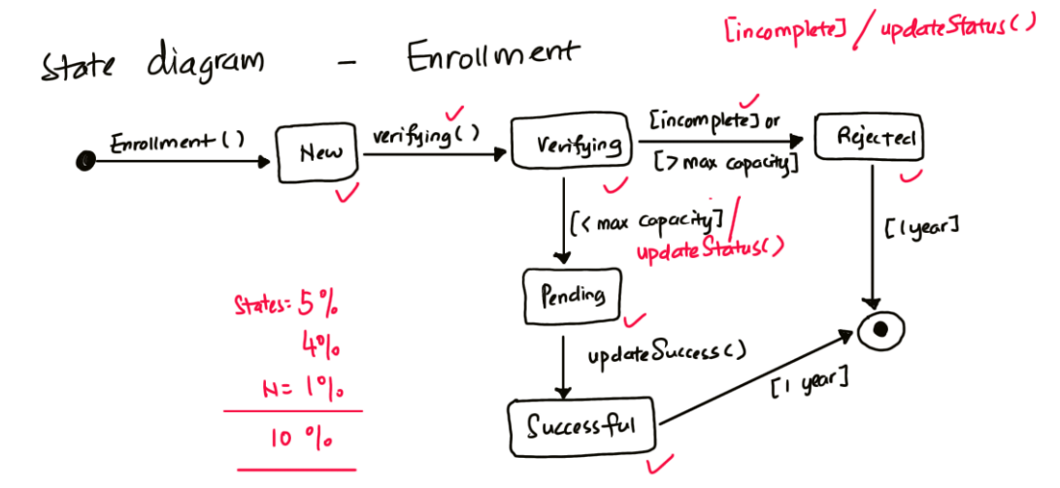

Q4
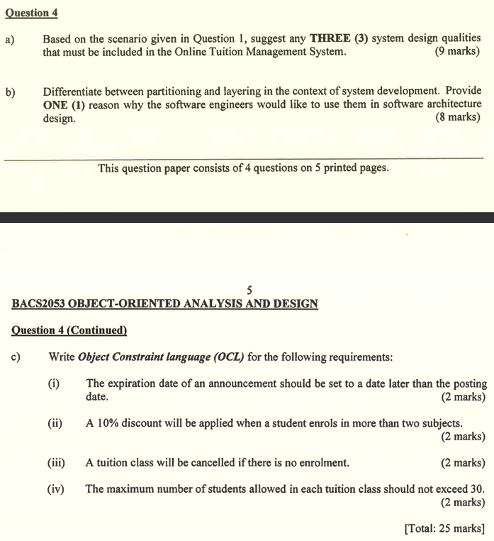

Junjun answer 🙂

(i) context Announcement inv: self.exp_date > self.post_date

(ii) context Student inv: self.enrollSubject->size() > 2 implies self.applicable_discount = 0.10

(iii) context TuitionClass inv: self.enrollStudent->isEmpty() = true implies self.status = ‘cancel’

(iv) context TuitionClass inv: self.enrollStudent->size() <= 30

